Curriculum Information – Year 3 – Autumn 1



RE  Prayers  We will be writing prayers for the people of different groups we belong to.  The Our Father Prayer | 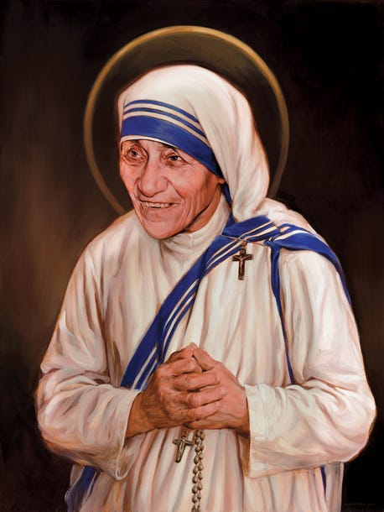  Year 3 Class Saint – Mother Teresa  During our transition sessions in July, Year 3 chose Mother Teresa to be their class Saint. They chose her because she was known for her charitable work, helped the poor and vulnerable and believed that she was sent on a mission to do God’s work and to help others.  She is the patron saint of World Youth Day and the Missionaries of Charity. Her Feast Day is September 5th.  Unit A: We Gather as God’s Family  Children will know;  - That Baptism is the Sacrament of Belonging to God’s Family, the Church.  - They will be able to identify some signs and symbols of Baptism and express their meaning.  - They will also be able to sequence the Rite of Baptism and discuss elements of the Celebration of Mass about gathering as the Family of God. | Gospel Values  Curious and Active    Children will be planning and delivering collective worship based around the Gospel Values each week.
English    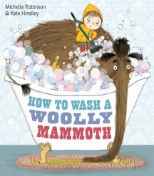  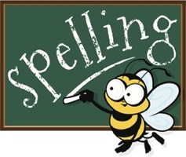 | 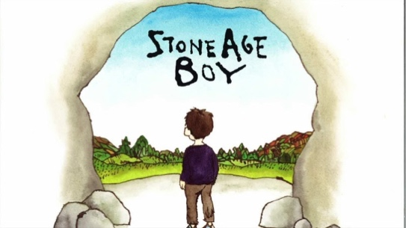  Transition Text – The Fox and the Star  - Rehearsal of basic skills, letter formation,  sentence structure and key grammatical features.  Narrative - Book focus: The Stone Age Boy  - Character and setting descriptions.  - Writing an alternative middle and ending.  Non-Fiction – Instructions: How to wash a Woolly Mammoth  - Writing instructions using adverbials of time and adverbs.  - Setting our instructions using the correct format.
Ongoing throughout this and each term will be a strong focus on spelling, punctuation and handwriting. Please help your child to practise these skills at home.

Spellings can be practiced on Emilie.
Reading  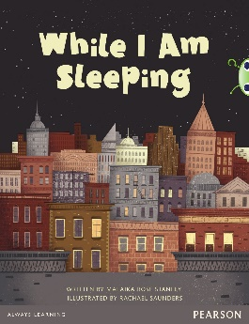 | Book focus: While I Am Sleeping by Malaika Rose Stanley  We will focus our reading skills around:  - Reading with fluency through daily practice.  - Learning new vocabulary and their definitions.  - Using evidence from the text to infer and retrieve information.  - Summarising what has happened and predicting what will happen next.  - Know which words are essential in a sentence to retain meaning.  - Explain the difference that the precise choice of adjectives and verbs make.
Maths  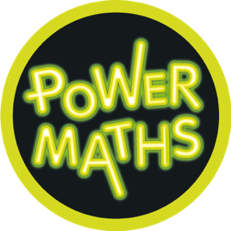 | Place Value  Children will be able to;  - Represent numbers to 100 and 1,000.  - Recognise each digit in a 3 digit number.  - Partition numbers into 1s, 10s and 100s.  - Use a number line to 1,000.  - Use a number line to estimate numbers.  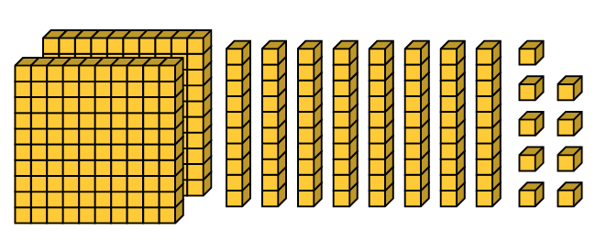  - Find 1, 10 and 100 more or less.  - Compare numbers to 1,000  - Order numbers to 1,000  - Count in steps of 4 and 8.  - Count in steps of 50 and 100.
Science   | Rocks and Soils  We will be;  - Comparing and grouping rocks based upon their appearance and other physical properties.  - Describing how rocks and fossils are formed in simple terms.  - Learning that soils are made from rocks and organic matter.
History  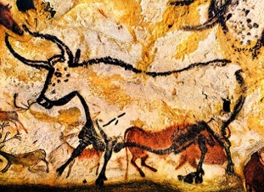 | Stone Age to the Iron Age  Children will be able to;  - Place ages in time order and understand the meaning of their names.  - Observe evidence from the past to ask questions and come to conclusions based on what I have seen.  - Suggest causes and consequences of the main events within pre history.  - Begin the explain the concept of change in history over a long period of time.  - Describe similarities and differences between the Stone Age, Bronze Age and Iron Age.
DT  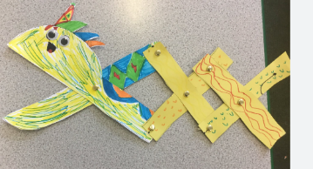 | Moving Monsters  Children will be able to –  - Understand that mechanisms are a collection of moving parts that work together as a machine to produce movement.  - Know that there is always an input and output in a mechanism.  - Know that an input is the energy that is used to start something working.  - Understand that an output is the movement that happens as a result of the input.  - Know that a lever is something that turns on a pivot.  - Understand that a linkage mechanism is made up of a series of levers.  To know some real-life objects that contain mechanisms.
French   | French greetings with puppets  Children will be able to –  - Look carefully at the speaker and respond confidently with the appropriate gesture and phrase.  - Begin to recognise how some sounds (‘on’, ‘ou’, ‘et’ and ‘oi’) are represented in written form.  - Link actions or pictures to the new language, both in spoken and written form. Imitate the pronunciation of sounds.  - Take turns to speak and use appropriate intonation.
Computing   | We are Programmers  Children will be able to –  - Design a sequence of instructions including directional instructions.  - Write programs that accomplish specific goals.  - Work with various forms of input.  - Work with various forms of output.  - Use a range of software for similar purposes.
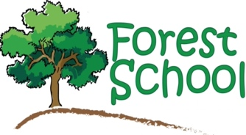 | Forest School  We are excited to announce that Year 3 will be taking part in some Forest School sessions on a Tuesday morning for the first half of the Autumn Term. These dates include 9.9.24, 16.9.24 and 30.09.24.  The children will need to bring in suitable clothes/shoes that you don’t mind getting dirty to wear for their morning session, warm and waterproof depending on the weather.
PE   | Football (Tuesday mornings and Wednesday afternoons)  Children will be able to –  - learn the basic rules, skills and techniques in Invasion Games (Passing, Receiving, Dribbling, Shooting)  Please ensure children have their kits in school on a Monday.
Music   | We are excited to welcome Mrs. Wallace as our new music teacher and she will be teaching our music session on a Wednesday.  This half term, we will begin to learn how to play the recorder. We will also learn how to read music, play the notes B and A and how to play pieces, in time, using these notes. We will focus on Native American music; exploring how the dimensions of music are used and know the indicators of this style.
PSHE  Meet Jigaw Jino!   | Being Me in My World  Piece 1 – Getting to know each other.    Piece 2 – Our Nightmare School.  Piece 3 – Our Dream School.  Piece 4 – Rewards and Consequences.  Piece 5 – Our Learning Charter.  Piece 6 – Owning our Learning Charter
Key events  for the half term | Y3 Meet the Teacher – Thursday 12th September at 5pm
Homework   | - Daily Maths homework will be given out each day.  - Weekly homework linked to the children’s learning will be given out on a Tuesday and should be returned by the following Monday.  - Reading at home should take place 5 times a week for 15 minutes. This will be monitored through daily diary checks. An adult must sign the diary to ensure they have read and been listen to each day.  - TT Rockstar’s, Emile Spellings and Letter Join handwriting are also online.

